**Sheriff’s Office Gallatin and Madison County**

***Missing Person***

Dr. Patrick J Fitzpatrick. 6’0” tall 250 pounds, white hair, Grey eyes, speaks with an Irish accent. Last seen Friday July 3, 2015 in the Bozeman area. Vehicle found Saturday July 4 south of Willow Cr.

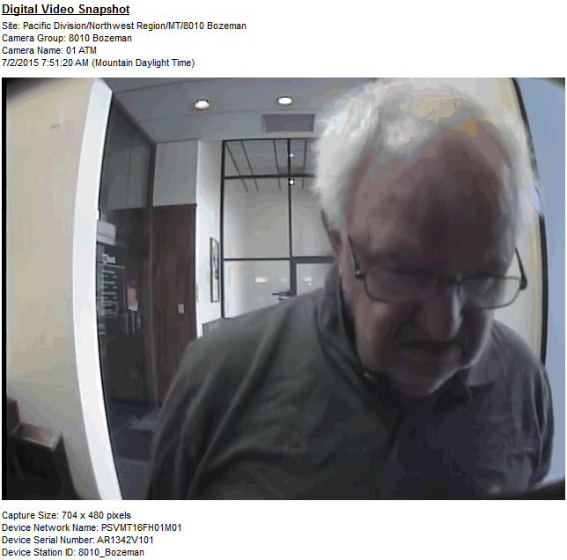

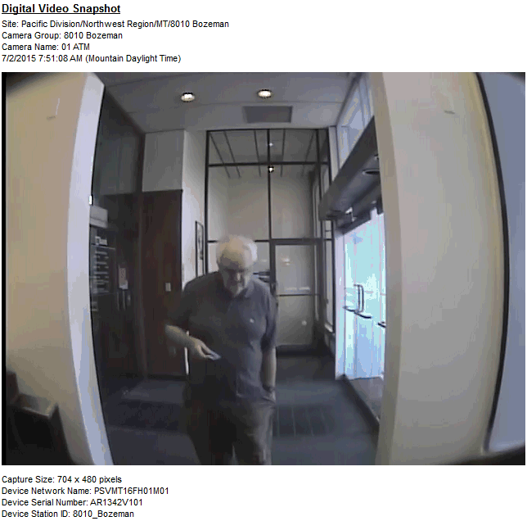

If you have information please contact the Gallatin or Madison County Sheriff at

Gallatin: 406-582-2100 or Madison: 406-843-5301