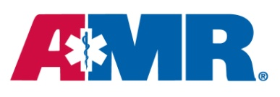

For Immediate Release

Contacts: Brian Hansen, (406) 697-6749

brian.hansen@amr.net

Rocco Roncarati, (360) 901-5795
rocco.roncarati@amr.net

Ambulances in Gallatin County Go Pink in October
To Highlight Breast Cancer Awareness Month

Bozeman, MT. - October 8, 2013 - American Medical Response of Bozeman Montana has wrapped one of its ambulances in eye-catching pink stripes to highlight AMR’s support for National Breast Cancer Awareness Month.
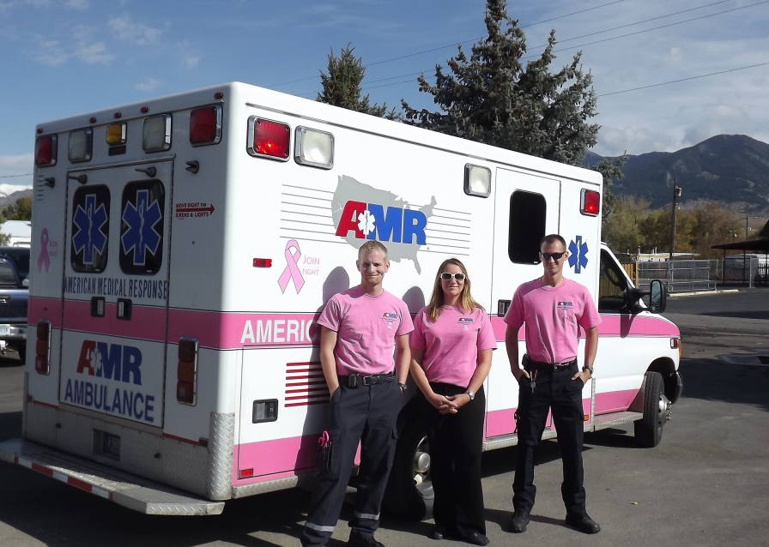
Local residents might do a double take when they see the hot pink ambulances at Gallatin County Operations, and our AMR caregivers also dressed in pink shirts. The AMR caregivers will wear pink shirts for the entire month of October to draw attention to the high rates of breast cancer and the need for increased awareness. The employees purchased the shirts themselves and half of the proceeds will be donated to breast cancer awareness efforts. So far, they have raised $750 and counting.

The shirts feature the pink breast cancer ribbon and say, “AMR, Raising Awareness in Montana.”
“As healthcare providers, we feel it’s important to join the effort to raise awareness of breast cancer risks, prevention and screening,” said Rocco Roncarati, general manager of AMR Operations. “Our employees have completely embraced this effort and can’t wait to drive the pink ambulance.”
For interviews, or to schedule a photo shoot, contact Rocco Roncarati.
About American Medical Response
American Medical Response Inc. (www.amr.net), America’s leading provider of medical transportation, provides services in 40 states and the District of Columbia. More than 18,000 AMR paramedics, EMTs, RNs and other professionals, with a fleet of 4,100 vehicles, transport more than three million patients nationwide each year in critical, emergency and non-emergency situations. AMR, a subsidiary of Envision Healthcare Corporation, is headquartered in Greenwood Village, Colorado.

